Handleiding PHP Unittest

# Introductie

[Unit testing with PHPUnit: Introduction (1/10) - YouTube](https://www.youtube.com/watch?v=k9ak_rv9X0Y)

[Unit testing with PHPUnit: Setting up PHPUnit (2/10) (youtube.com)](https://www.youtube.com/watch?v=cQucsmbOkpE)

[Unit testing with PHPUnit: Writing your first test (3/10) (youtube.com)](https://www.youtube.com/watch?v=yYbKgv7WCt4&t=107s)

# Installatie composer

[Introduction - Composer (getcomposer.org)](https://getcomposer.org/doc/00-intro.md#using-the-installer)

Download and run [Composer-Setup.exe](https://getcomposer.org/Composer-Setup.exe). It will install the latest Composer version and set up your PATH so that you can call composer from any directory in your command line.

Test installatie:

Type cmd in windows search en run de Opdrachtprompt of open een terminal in Visual Studio Code  
Type composer -V

# Installatie PHP Unit

**Stappen:**

1. cmd
2. cd Dowloads
3. mkdir test
4. cd test
5. pak de zip ‘code voor unittest.zip’ uit.  
   Je moet de mappen **src** en **test** in de map Downloads/test hebben staan.
6. Doe vervolgens het commando: **composer init**

Welcome to the Composer config generator

This command will guide you through creating your composer.json config.

Package name (<vendor>/<name>) [robwi/opdracht_unittest_calculator]: **<enter>**

Description []: <enter>

Author [Rob Wigmans <45373471+robwigmans@users.noreply.github.com>, n to skip]: **<enter>**

Minimum Stability []: **<enter>**

Package Type (e.g. library, project, metapackage, composer-plugin) []: **<enter>**

License []: **<enter>**

Define your dependencies.

Would you like to define your dependencies (require) interactively [yes]? **no**

Would you like to define your dev dependencies (require-dev) interactively [yes]? **<enter>**

Search for a package: **phpunit/phpunit**

Enter the version constraint to require (or leave blank to use the latest version): **<enter>**

Cannot use phpunit/phpunit's latest version 12.0.10 as it requires php >=8.3 which is not satisfied by your platform.

Using version ^11.5 for phpunit/phpunit

Search for a package:

Add PSR-4 autoload mapping? Maps namespace "Robwi\OpdrachtUnittestCalculator" to the entered relative path. [src/, n to skip]: **<enter>**

{

"name": "robwi/opdracht_unittest_calculator",

"require-dev": {

"phpunit/phpunit": "^11.5"

},

"autoload": {

"psr-4": {

"Robwi\\OpdrachtUnittestCalculator\\": "src/"

}

},

"authors": [

{

"name": "Rob Wigmans",

"email": "robwigmans@users.noreply.github.com"

}

],

"require": {}

}

Do you confirm generation [yes]? **<enter>**

Would you like to install dependencies now [yes]? **<enter>**

1. **Aanpassen composer.json file**

"name": "rob/opdracht_unittest_calculator",

    "require-dev": {

        "phpunit/phpunit": "^11.5"

    },

    "autoload": {

        "psr-4": {

            "VoorbeeldUnittest\\": "src/"

        }

1. **Type: vendor\bin\phpunit --generate-configuration**

PHPUnit 11.5.15 by Sebastian Bergmann and contributors.

Generating phpunit.xml in C:\Users\robwi\Downloads\opdracht_unittest_calculator\opdracht_unittest_calculator

Bootstrap script (relative to path shown above; default: vendor/autoload.php): **<Enter>**

Tests directory (relative to path shown above; default: tests): **<Enter>**

Source directory (relative to path shown above; default: src): **<Enter>**

Cache directory (relative to path shown above; default: .phpunit.cache): **<Enter>**

Generated phpunit.xml in C:\Users\robwi\Downloads\opdracht_unittest_calculator\opdracht_unittest_calculator.

1. Indien er extra mappen bijkomen moet er een **composer update** uitgevoerd worden.

Maak een fout in de code: verander 3 in een 4 in de functie in app/Calculator.php

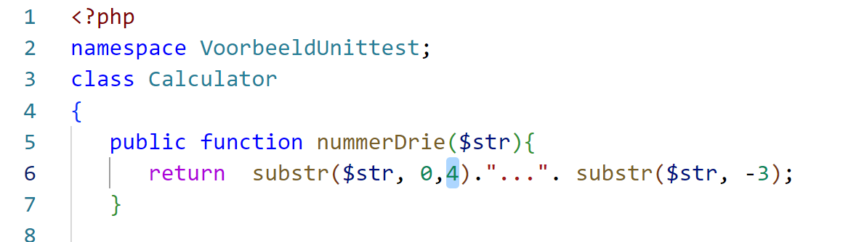

Test  
Verwachtte uitkomst is “abc…xyz” als je “abcde…. vwxyz” meegeeft aan de method.

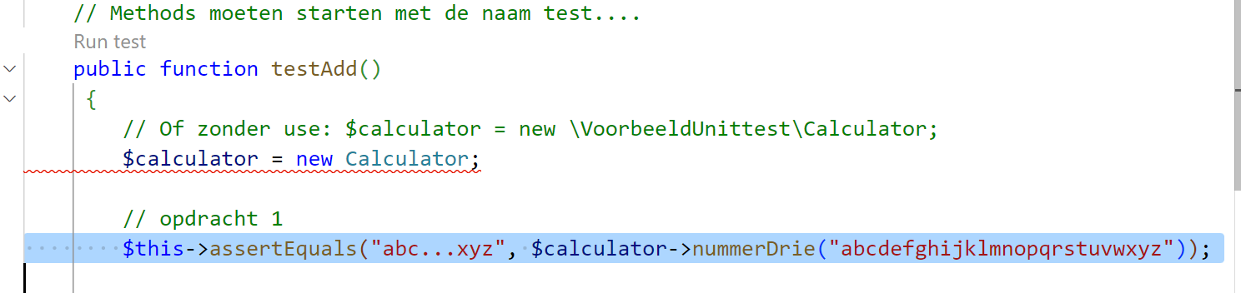

Uitvoeren van de test:

vendor\bin\phpunit

Resultaat

Zie verder de meer informatie in de volgende link.

[PHPUnit – The PHP Testing Framework](https://phpunit.de/)

Manual Tests

[1. Assertions — PHPUnit 9.5 Manual](https://phpunit.readthedocs.io/en/9.5/assertions.html#assertequals)